Table of contents
Introduction 3
What a mental health policy? And its importance 3
Impatient mental health facilities and services 3
Case Scenario 5
Community Respond Team 5
Police and health services 5
Project visions 6
Use case Diagram 7
Use case of the Project architecture 8
Precautions 9
Conclusion 10
References 11

Introduction:

When patients are released directly from the respective authority, there is no process to inform the community based mental health service. They left unnoticed about the unplanned discharge or ant relevant cases. This become a serious issue to the authority. When mental health or mental disorder conditions are untreated, it refers to a crime to the authority. This psychiatric condition may lead to major issues. Even it can be a suicidal attempt. On the other hand, forensic expert said that ex-prisoners often miss out on the mental health system. In this report, youth assigned to a head space case worker may subsequently got admitted to the ED (emergency department) of the regional hospital (Hardinget al. 2007). But the process lags in case of some loopholes. It mainly happens when a client has been released, but the case worker get too notified lately. Eve in some cases, the case worker did not get any notification regarding the patient or the client. In may happen that after returning to that environment the young person tends to take suicidal attempt.

What a mental health policy? And its importance:

Mental health polices mainly describes the values, objectives and strategies of the government t reduce the mental health related issues to establish a stable situation. However policies demonstrates the strategy to overcome an issue. In this report, the process and models will help to mitigate the gap between them (Kessler, Cleary, & Burke, 2006).

Impatient mental health facilities and services:

The services of the public mental health care for the children, older people as well as youths provide mental health related services. This type of facility is provided in the community based clinics, local health cares, and residential hospitals etc. it can be whether private based organizations or an initiative taken up by the government.
The outline structure shows the patient pathway through the mental health system. The whole working methodology explaining whole structure (Wilson, 2006). Even the flow of process also indicates the individual units and their advantages and disadvantages. So a screening can be done for the further improvement of the system.

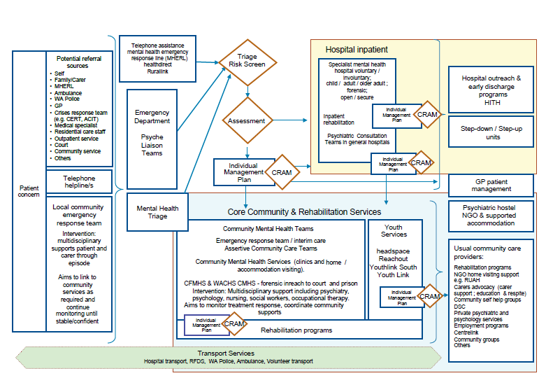
Figure 1: Mental Health Patient pathway (Model)

It acknowledges the commanding structure of the mental health services and headspace structure or relation between them. It even elaborates more precisely. On the other hand, it also minimizes the risk of self-harm. Therefore, suicidal attempts still became a link to harm the whole structure and points to its efficiency. In that case, mental health services are neededto conduct risk assessment at any crucial stage of a client. Even if the patient leaves the services, the risk assessment also needed in that scenario (Luoma, Martin, & Pearson, 2014).
Nevertheless, moving form one constituent or portion of mental health service to another, the patient path is not smooth. Indeed, the necessity of repeating regulation and assessment is needed as a barrier of entry.
Case Scenario:
It refers to the risk assessment of the patient before discharge. On the other hand, the individual management plan and a case summary letter is produces to account all the details of the youth or the patient. However, when the patient reach the mental health facility, the whole process is repeated and an outcome of the decision identifies whether a further treatment is needed or not (Seidl et al.2015).

Community Respond Team:
In most of the metropolitan area, the first psychiatric emergency response team provides twenty four hours of services and emergency responses. Even this type of idea was continuing since nineteen’s. However, the rapid growing of mental health issues and urgent assessment expanding the community of mental health services. The mental illness effect has been increasing due to the excessive pressure at work, neurological problemsetc. Hence forth, the necessity is becoming high asking for more services.Tso expansion of up gradation in needed in medical response services (Ajaykumar, & Prasad, 2014).
Even municipalities has expanded their response teams up to seven or eight. The response time must be twenty four hour to give proper services in case of emergency.
Even CERT took necessary steps regarding the clinical policies and mental health issues. The model describes and tends to mitigate the issues regarding the matter.

Police and health services:
The incidents helps the police to track and investigate the case in case of details gathered from mental health center’s or response teams (Luoma, Martin & Pearson, 2014). It includes incidents in the community where a client or a person:
- Has an history of violence
- A threat to the others at the Service Centre.
- Even a threat to property.
- Has a high level of distress.
- Dedicated to harm himself desperately.

Figure
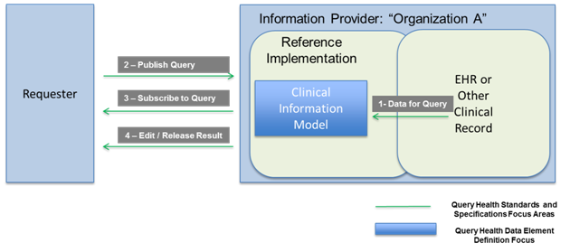
Figure 2: Query regarding patient’s methodology.

In this case a multiskilled team is needed, which consist of police, ambulance, and mentalhealthexperts. Police mainly helps to provide security services in case of an emergency. Query can be generated by any respected authority regarding the ill patient. In the figure the requester publish query to the information provider or mental health services (Hazra, & Dey, 2014). They goes through a clinical internal procedure to collect and provide all necessary details to the requester.

Project visions:

Vision mainly focuses only one thing. However, it consists of modules or set of modules implementing or represents the whole policy.
- Mental health context is the foremost module that incorporate with the core polices.
- Mental health policies and plans helps to construct regulations on certain circumstances.
- Financing of the project is another important and core part, than enhances the methodologies to be implemented to provide a solution for the scenarios in case of unmodified condition.
- Legislation and human rights also be taken into consideration (Li& Jiang,2014).
- Quality improvement is the process of improving the previous model and implementations
- Organizational services are the services are the facilities provided to the client under any medical emergency or any other circumstance. Even client satisfaction is also included having well and proper services. However, the services should be on time. Services like ambulances. Transferring from any department to another department
- Even psychotropic drugs are given to improve in case of a client faces any critical condition.
- Project vision also covers the QOS or the quality of services.
- Information should be set up to store or manipulate information’s about the client in a short period.
- Research and evaluation of policy and services are included and a part of rapid up gradation of the whole system (Al-Fedaghi, 2014).

Use case Diagram:
Use case diagram represents the user’s interaction with the current system which facilitates the relation between the user and the different use cases. The methodology is to demonstrate the activities performed based on different perspectives. It also identify the different types of users and different types of use cases following differ types of working methodology. A use case is the relation between a registered user and an attribute. The relation reflects the nature of relationship and working methodology. It is developed by the Unified Modeling language as an actor and a system. The main goal is to establish a relationship between them. The actor may be a human or an external entity or system. Software engineering is done to develop this kind of system.
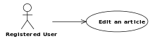

Figure 3:Use Case

Use case of the Project architecture:

System modelling is the foremost activity in developing a mental health care system structure (Al-Fedaghi, 2014). The different things that are the important part of the developed system are external perspective, interaction between modules, structural design as well as behavioral.

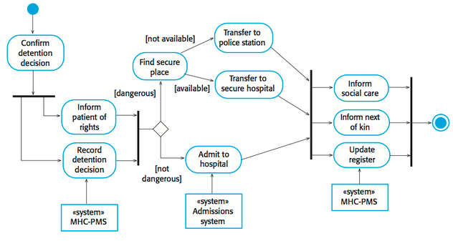
Figure 4: Use Case Architecture

Interaction has been described into three manner User interaction, system to system interaction and component interaction. In the use case medical receptionist transfer data to the patient record system

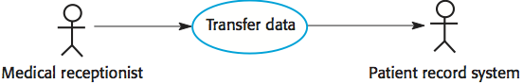

Figure 5: A Part of the Use Case

In the architecture, confirm detection decision is connected to two part as inform right of patients and record detention decision also. System are connecting and working each other by an arrow in the picture. However, a system MSC-PMS is fed to the record detention entity. If the admitted client or mentally ill person is dangerous he or she should be shifted to a secure place. It can be done by finding secure place activity. On the other hand he is not dangerous, he is referred to the hospital (Seidlet al. 2015). There a system administration system will work on the activity or entity. However, find secure place lead to two different palace.it can be police station or any secure hospital where he will be separated from others. Therefore it will be forwarded to inform social care, inform next of kin. In this level user can also be updated depending on the situation or the policy to avoid any risk. The starting as well as end of an activity is represented as a mark. The arrows refers to the work flow of the whole structure.

Precautions:
The foremost precaution in the designing part is the correct work flow analysis of the system. If it is not done properly, it may lead to system isolation and also violate the risk policy.
Another important issue is the up gradation of users or clients after discharge. If it is not configured properly, this could lead to a risk issue to the client. In most of the cases the, sudden discharge without notifying the headspace staff. In the meantime, the youth tend to back to that environment and take suicidal attempts. So a proper mechanism in this architecture (update) can mitigate the issues.

Conclusion:
In this use case diagram, the issues are mitigated. Still a proper risk assessment is needed to further development of the system with time. This will facilitate the benefits and also improve efficiency and affectivity.Inter-agency communication gap will be solved.

References:

Harding, T. W., De Arango, V., Baltazar, J., Climent, C. E., Ibrahim, H. H. A., Ladrido-Ignacio, L., & Wig, N. N. (2007). Mental disorders in primary health care: a study of their frequency and diagnosis in four developing countries. Psychological medicine, 10(02), 231-241.

Kessler, L. G., Cleary, P. D., & Burke, J. D. (2006). Psychiatric disorders in primary care: results of a follow-up study. Archives of General Psychiatry, 42(6), 583-587.

Beautrais, A. L., Joyce, P. R., Mulder, R. T., Fergusson, D. M., & Nightingale, S. K. (2009). A Case-Control Study. Am J Psychiatry, 153, 1009-1014.

Whooley, M. A., Avins, A. L., Miranda, J., & Browner, W. S. (1997). Case-finding instruments for depression. Journal of general internal medicine, 12(7), 439-445.

Wilson, R. M., Runciman, W. B., Gibberd, R. W., Harrison, B. T., Newby, L., & Hamilton, J. D. (2006). The quality in Australian health care study. Medical Journal of Australia, 163(9), 458-471.

Luoma, J. B., Martin, C. E., & Pearson, J. L. (2014). Contact with mental health and primary care providers before suicide: a review of the evidence. American Journal of Psychiatry.

Seidl, M., Scholz, M., Huemer, C., & Kappel, G. (2015). The Use Case Diagram. In UML@ Classroom (pp. 23-47). Springer International Publishing.

Ajaykumar, S. D., & Prasad, M. S. (2014). Transforming data flow diagram to use case diagram. International Journal of Management, IT and Engineering, 4(1), 561.

Luoma, J. B., Martin, C. E., & Pearson, J. L. (2014). Contact with mental health and primary care providers before suicide: a review of the evidence. American Journal of Psychiatry.

Hazra, R., & Dey, S. (2014). Consistency between Use Case, Sequence and Timing Diagram for Real Time Software Systems. International Journal of Computer Applications, 85(16).

Li, Y., & Jiang, L. (2014, August). The research on test case generation technology of UML sequence diagram. In Computer Science & Education (ICCSE), 2014 9th Internation

Al-Fedaghi, S. (2014). Information system requirements: a flow-based diagram versus supplementation of use case narratives with activity diagrams. International Journal of Business Information Systems, 17(3), 306-322.

